22-1、Motor Driver DRV8833

1. 参考《0-1》文档，插入ESP32模块。
2. 用导线连接IO口与电机控制口，如下图所示：

红色线<------->MOTOR_A（1号电机正极）

绿色线<------->MOTOR_B（1号电机负极）

蓝色线<------->MOTOR_C（2号电机正极）

黑色线<------->MOTOR_D（2号电机负极）

棕色线<------->MOTOR_E（3号电机正极）

粉色线<------->MOTOR_F（3号电机负极）

黄色线<------->MOTOR_G（4号电机正极）

紫色线<------->MOTOR_H（4号电机负极）

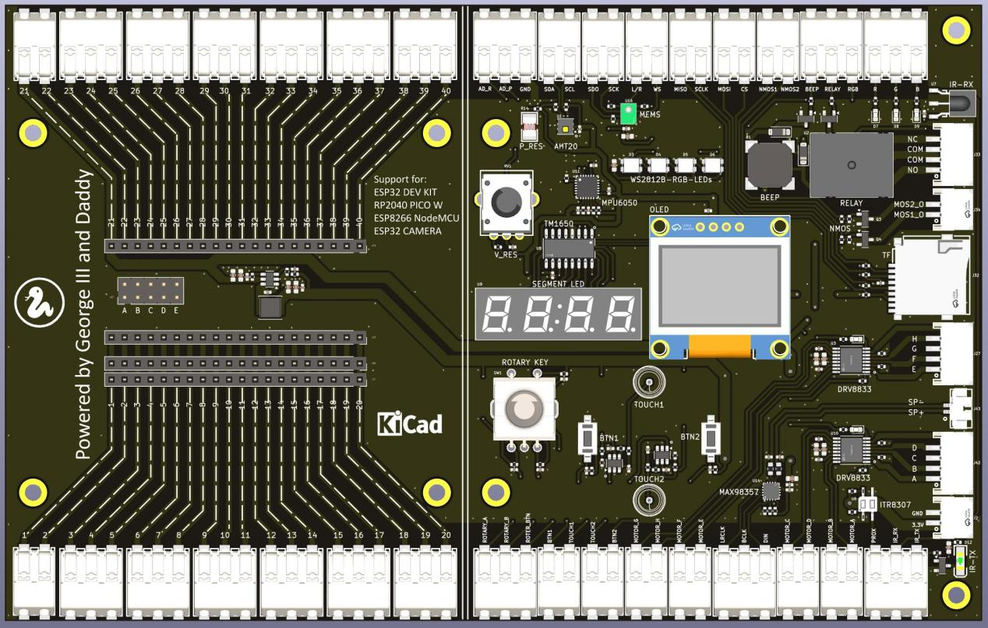

1. 代码示例

#main.py

from machine import RTC,Pin,Timer

import time

# create output pin

Motor_A_Pin = 16

Motor_B_Pin = 17

Motor_C_Pin = 18

Motor_D_Pin = 19

Motor_E_Pin = 12

Motor_F_Pin = 14

Motor_G_Pin = 27

Motor_H_Pin = 26

Motor_A = Pin(Motor_A_Pin, Pin.OUT)

Motor_B = Pin(Motor_B_Pin, Pin.OUT)

Motor_C = Pin(Motor_C_Pin, Pin.OUT)

Motor_D = Pin(Motor_D_Pin, Pin.OUT)

Motor_E = Pin(Motor_E_Pin, Pin.OUT)

Motor_F = Pin(Motor_F_Pin, Pin.OUT)

Motor_G = Pin(Motor_G_Pin, Pin.OUT)

Motor_H = Pin(Motor_H_Pin, Pin.OUT)

def do_motor_init():

Motor_A = Pin(Motor_A_Pin, Pin.OUT, Pin.PULL_UP)

Motor_A = Pin(Motor_A_Pin, Pin.OUT, value=1)

Motor_A = Pin(Motor_A_Pin, Pin.OUT, drive=Pin.DRIVE_3)

Motor_B = Pin(Motor_B_Pin, Pin.OUT, Pin.PULL_UP)

Motor_B = Pin(Motor_B_Pin, Pin.OUT, value=1)

Motor_B = Pin(Motor_B_Pin, Pin.OUT, drive=Pin.DRIVE_3)

Motor_C = Pin(Motor_C_Pin, Pin.OUT, Pin.PULL_UP)

Motor_C = Pin(Motor_C_Pin, Pin.OUT, value=1)

Motor_C = Pin(Motor_C_Pin, Pin.OUT, drive=Pin.DRIVE_3)

Motor_D = Pin(Motor_D_Pin, Pin.OUT, Pin.PULL_UP)

Motor_D = Pin(Motor_D_Pin, Pin.OUT, value=1)

Motor_D = Pin(Motor_D_Pin, Pin.OUT, drive=Pin.DRIVE_3)

Motor_E = Pin(Motor_E_Pin, Pin.OUT, Pin.PULL_UP)

Motor_E = Pin(Motor_E_Pin, Pin.OUT, value=1)

Motor_E = Pin(Motor_E_Pin, Pin.OUT, drive=Pin.DRIVE_3)

Motor_F = Pin(Motor_F_Pin, Pin.OUT, Pin.PULL_UP)

Motor_F = Pin(Motor_F_Pin, Pin.OUT, value=1)

Motor_F = Pin(Motor_F_Pin, Pin.OUT, drive=Pin.DRIVE_3)

Motor_G = Pin(Motor_G_Pin, Pin.OUT, Pin.PULL_UP)

Motor_G = Pin(Motor_G_Pin, Pin.OUT, value=1)

Motor_G = Pin(Motor_G_Pin, Pin.OUT, drive=Pin.DRIVE_3)

Motor_H = Pin(Motor_H_Pin, Pin.OUT, Pin.PULL_UP)

Motor_H = Pin(Motor_H_Pin, Pin.OUT, value=1)

Motor_H = Pin(Motor_H_Pin, Pin.OUT, drive=Pin.DRIVE_3)

print("do_motor_init")

def do_rotate_CCW():

Motor_A.value(0)

Motor_B.value(1)

Motor_C.value(0)

Motor_D.value(1)

Motor_E.value(0)

Motor_F.value(1)

Motor_G.value(0)

Motor_H.value(1)

def do_rotate_CW():

Motor_A.value(1)

Motor_B.value(0)

Motor_C.value(1)

Motor_D.value(0)

Motor_E.value(1)

Motor_F.value(0)

Motor_G.value(1)

Motor_H.value(0)

def do_brake():

Motor_A.value(1)

Motor_B.value(1)

Motor_C.value(1)

Motor_D.value(1)

Motor_E.value(1)

Motor_F.value(1)

Motor_G.value(1)

Motor_H.value(1)

def do_taxiing():

Motor_A.value(0)

Motor_B.value(0)

Motor_C.value(0)

Motor_D.value(0)

Motor_E.value(0)

Motor_F.value(0)

Motor_G.value(0)

Motor_H.value(0)

do_motor_init()

while True:

do_rotate_CW()

time.sleep_ms(1000)

do_taxiing()

time.sleep_ms(5000)

do_rotate_CCW()

time.sleep_ms(1000)

do_brake()

time.sleep_ms(5000)

1. 上传main.py到模块中，按F5或点击运行按钮，就可以看见4个直流电机一会正转一会反转。

下图中红色箭头所指为电机驱动芯片DRV8833，绿色框内接口接直流电机（AB、CD、EF、GH分别接直流电机正负极），红色框内接口为控制信号连接到ESP32模块上。电机的选择需在DRV8833的驱动能力之内。

